Evolution is an illusion

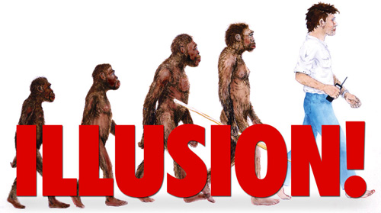

These kinds of images are floated around to brain wash people.

**Drawings of Dinosaurs Can be found in caves. Please scroll below to see the images drawn by human beings. There is no way they could have drawn these unless humans saw Dinosaurs.**



