Journaling

Instructions: Please save this document in your computer. On the day of Journaling (actually, the previous evening is better) open a new document, if keeping the journal electronically. If using a notebook, open a new page. Spend 5 minutes reading today’s mass readings. Pray to the Holy Spirit begging Him to forgive our sins and make you worthy to be in His presence. Use the guide below and read the Bible passage according to the day you are in. If you are in Day 3, for example, read Psalm 24 slowly. Ask God to search your heart and tell you the areas you need change in your life. Not only spiritual life but life in general. It can be eating habit or entertainment, etc. Write in your journal any thought that comes to you. Trust the Lord. Spend 5 minutes here.

Then, move on to Praise and Thanksgiving. Read Colossians 3:16, if you are in Day 3. Write in your journal anything that comes to your mind. 5 minutes here.

Then, move on to Get Intimate with God section. If you are in Day 3, you will be praying for your community. 5 minutes here.

SEARCH ME

Search me, O God, and know my heart; test me and know my anxious thoughts. See if there is any offensive way in me, and lead me in the way everlasting.

Psalm 139:23-24

This is the section where you quiet yourself before the Lord and ask Him to show you any areas of sin in your heart that need to be addressed. This step is so important to the Father that Jesus told us in Matthew 5:23 that if we are coming to do business with God, and we remember a problem between ourselves and another, we are to leave our gift and go make things right with that person. Then come back and offer the gift. Being in right standing with God and man to the best of our ability is an important first step to having our prayers heard on high.

We all sin and fall short daily, this is a fact. Starting your prayer time in Search Me allows you the opportunity to do a heart check.

DAY 1- Start your prayer time by praying Psalm 51.

DAY 2- Meditate on Matthew 5:8. Ask God to show you anything in your heart that does not please Him.

DAY 3- Start your prayer time by reading Psalm 24.  Ask God to show you any idols in your heart.

DAY 4- Ask for the blessing mentioned in Ezekiel 36:26.

DAY 5- Read and meditate on Psalm 78.  Thank God for His mercy towards you.

DAY 6- Read and mediate on Proverbs 20. Ask the Lord to show you any un-forgiveness in your heart.

DAY 7- Meditate on Romans 12.

PRAISE & THANKSGIVING

Enter His gates with thanksgiving and His courts with praise; give thanks to Him and praise His name.

- - Psalm 100:4

Praise & Thanksgiving section, make sure to give Him both thanksgiving and praise. Bless God with the fruit of your lips. Thank Him for any truths He shows you about yourself in the Search Me section. Thank Him for being the God of glory who answers prayer. Reflect on the magnificent fact that it is His Spirit that prays through you, and it is also His Spirit that will answer those prayers (Romans 8:26-27). He is truly the Intercessor and the Amen. The buck starts and ends with Him!

DAY 1- Write a poem to the Lord about His goodness.

DAY 2- Read Psalm 117 and meditate on it. Think about a time when God has been good to you, and a time that He has shown His faithfulness to you.

DAY 3- Start your time by reading Colossians 3:16. Make up a new song to sing before the Lord.

DAY 4- Read Psalm 127.  Thank God for being the foundation that everything of worth is built upon in your life.

DAY 5-Read Psalm 147 and replace Israel and Jerusalem with your name and your family’s name.

DAY 6- Write a love letter to God.

DAY 7- Thank the Lord for His promises outlined in Zephaniah 3:17.

GET INTIMATE WITH GOD

I no longer call you servants, because a servant does not know his master’s business. Instead, I have called you friends, for everything that I learned from my Father I have made known to you.

John 15:15

Spirit led prayer is first hearing the heart of Jesus, then praying His heart back into the earth. Now that you have spent time in the Search Me and Praise & Thanksgiving sections, you are ready to do just that.

Now it’s time to hear the Lord’s heart concerning

your Family

your Enemies

your Community

The Lost

The Church

Government

whatever else He puts on your heart in the Freestyle section. Choose one sub-category for each day of the week and spend time journaling your prayers in that section.

FAMILY

Behold, how good and pleasant it is when brothers live together in unity. It is like precious oil poured on the head, running down on the beard, running down on Aaron’s beard, down upon the collar of his robes. It is as if the dew of Hermon were falling on Mount Zion. For there the Lord bestows his blessing, even life forevermore. - Psalm 133:1

This is the section where you ask yourself the question,

“How is my family really doing?”

Who is thriving, and who is hanging on by a thread?

Is your family a strong unit, or is there fighting and dissention among you?

Is there anyone in your family in bondage to any form of substance abuse?

Are there orphans and widows among you?

How are the marriages in your family doing?

What about the next generation, how are the children?

If you are married don’t forget to also lift up prayers and petitions for your in-laws.

Is there anyone in your family who doesn’t know the love of Jesus?

If any member of your family were to close their eyes in eternal rest tonight, could you be absolutely sure where they would spend eternity?

WEEK 1: Meditate on 1Timothy 5 and 1 Corinthians 13. Pray for real love, and charity to abound in your family. Ask God to show you practical ways to be a blessing to family members.

WEEK 2: Read Acts 16:16-34. Stand on the promise Paul made the jailer as you pray for your family, “If you believe on the Lord Jesus, you and your whole household will be saved."

WEEK 3: Read Numbers 35:9-21 and Ephesians 6:10-18. Our battle is not against flesh and blood, so what spiritual enemies are attacking your family members today?

WEEK 4: Start your prayer time by meditating on Malachi 4, Matthew 18:1-7, and Psalm 127. Pray for the children in your family, come against the negative influence of the culture on their lives. Pray also that they would be protected from predators.

WEEK 5: Read Genesis 2:24, and Ephesians chapter 5. Pray for marriages in your family.

WEEK 6: Read Acts 2, pray that God’s spirit of revival would be poured out on

WEEK 7: Read Joshua 24:1-15. Joshua starts by recalling Israel’s history with God. He ends by renewing his family’s covenant to serve God. Write a brief account of your family’s history with God. Renew your covenant with God on behalf of your family.

My Enemies:

Luke 6:27-29

Spending intentional, dedicated time in prayer for our enemies is one of the best ways to keep our hearts free of bitterness.

In God’s economy, harboring un-forgiveness in our hearts is an absolute ‘no-no’. The God of Glory will not abide the hypocrisy of un-forgiveness when He has forgiven us so much.

WEEK 1: Read Proverbs 24. Pray for your enemies as the Holy Spirit leads you.

WEEK 2: Read Romans 12. Pray for your enemies as the Holy Spirit leads you.

WEEK 3: Read Psalm 57. Pray for your enemies as the Holy Spirit leads you.

WEEK 4: Read Psalm 25. Pray for your enemies as the Holy Spirit leads you.

WEEK 5: Read Matthew 26. Think of all the ways Jesus was betrayed. Ask the Lord to give you His heart for your enemies.

WEEK 6: Pray Psalm 37. Pray for your enemies as the Holy Spirit leads you.

WEEK 7: Meditate on Luke chapter 6. Pray for your enemies as the Holy Spirit leads you.

The Church:

Haggai 1:5-11

God’s church should carry the kind of spiritual muscle that shifts atmospheres and regions, the kind of clout that causes the heavens to drop their dew and crops to grow. The church should have the type of authority that causes social and economic prosperity to enter a region just because the people of God are there.

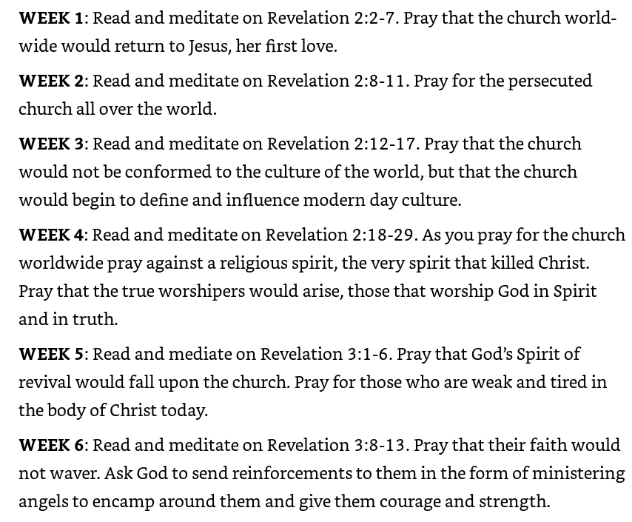



The Lost:

Luke 5:1-11

